Portfolio-2

COIT20268 - Responsive Web Design (RWD)

(Term 2 – 2019)

Made by: Narola Shraddha Ghanshyambhai(12082733)

Tutor: Shawkat Ali

Table of Contents

Portfolio2.1 (Chapter 7)1

Portfolio2.2 (Chapter 8)13

Portfolio2.3 (Chapter 9)13

Portfolio2.4 (Chapter 10)16

Portfolio2.5 (Chapter 11)18

Portfolio2.6 (Chapter 12)20

Portfolio2. Summary20

**Portfolio 2.1 (Chapter 7)**

Following designs of site pages are appeared beneath which are drawn by utilizing inscape drawing chrome expansion through which designer can have thought regarding website page for work area screen in scene and portrait with 1024x768 to 1280x1024 pixels and Mobile Screen 500x720 pixels. For model, landing page will have header, footer, left sidebar, content segment and so on.

**Homepage**

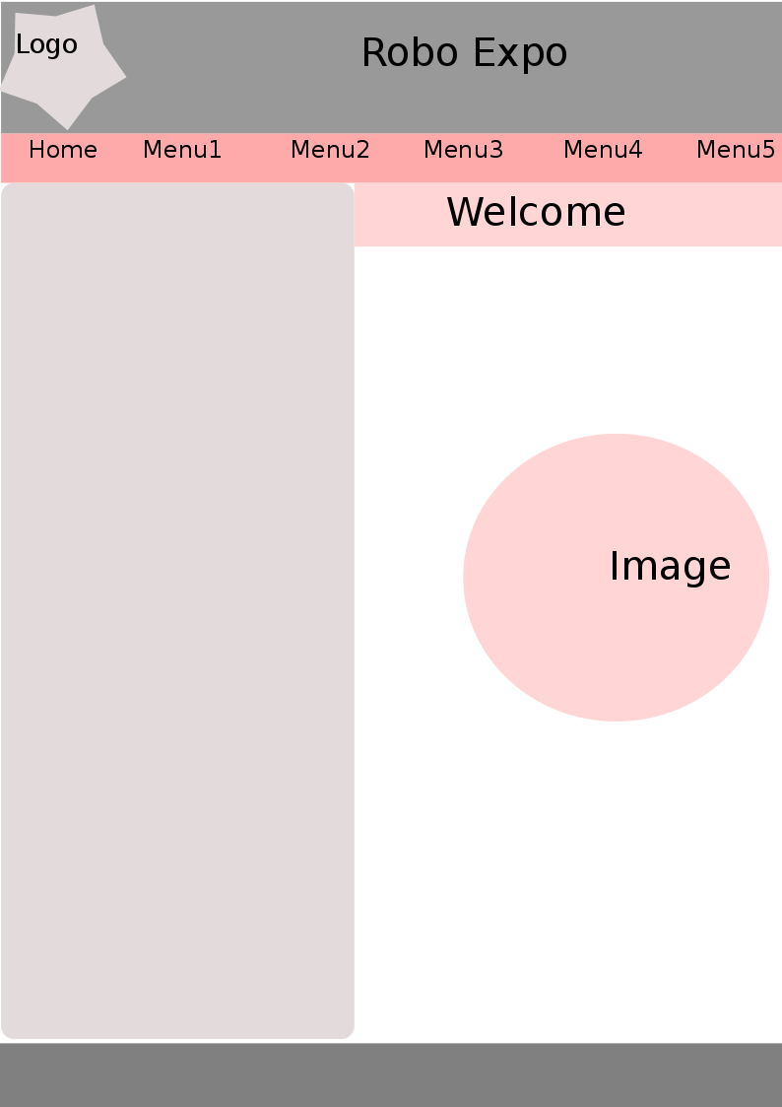

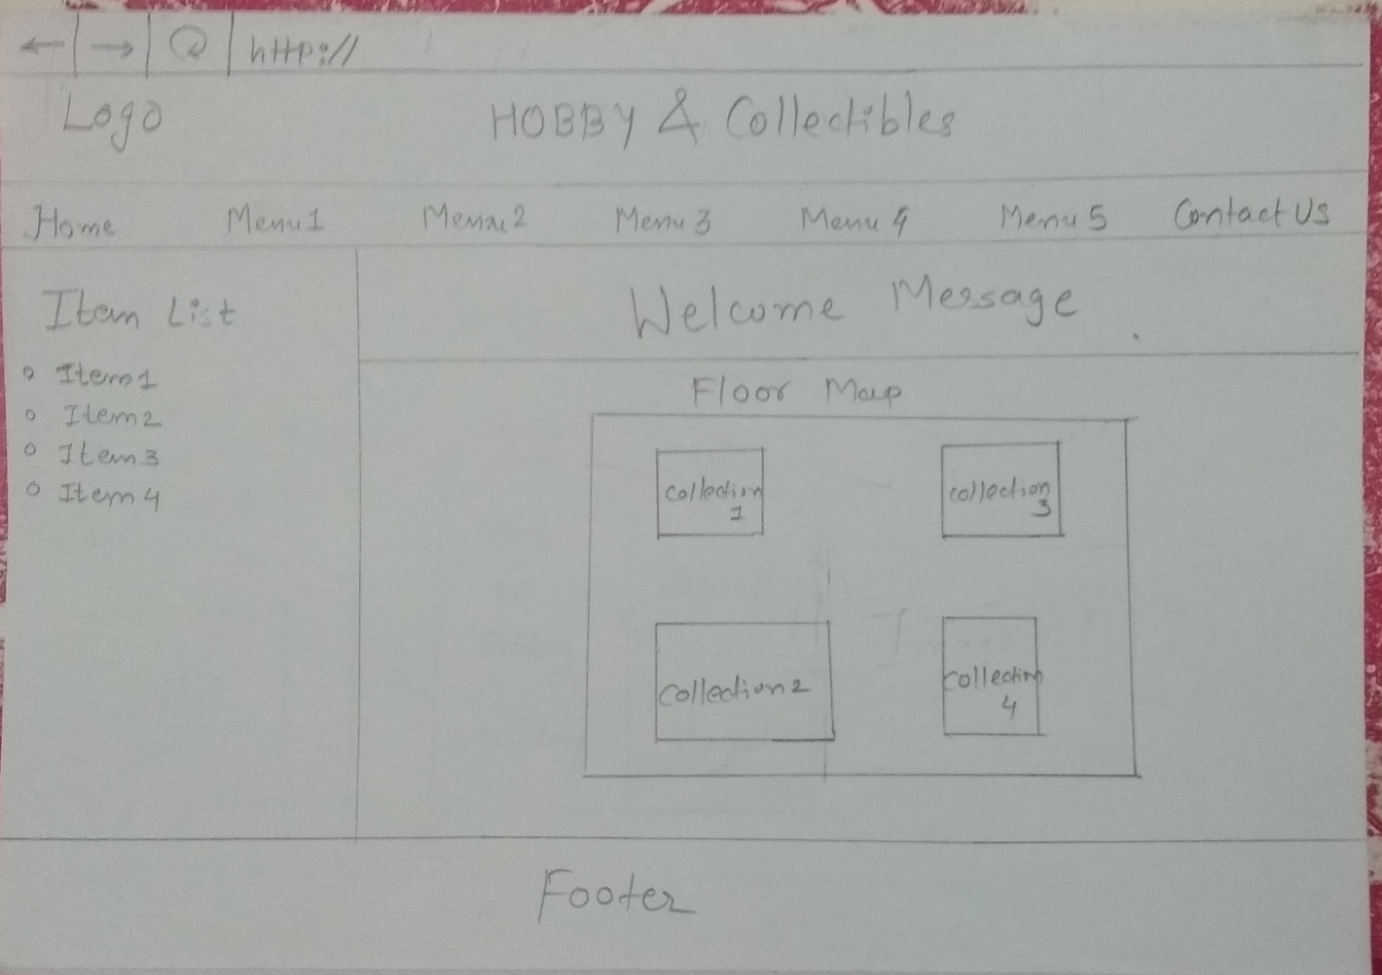

**Antiques Collections**

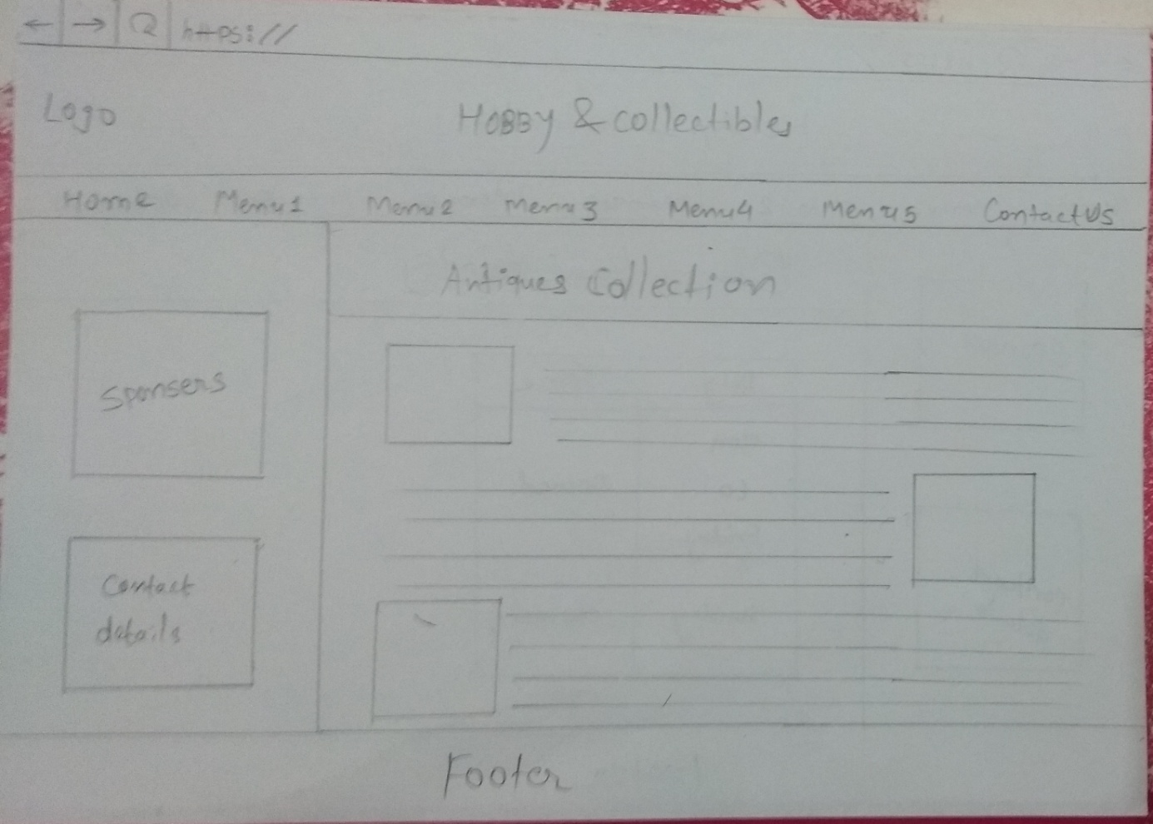

**Stamps Collections**

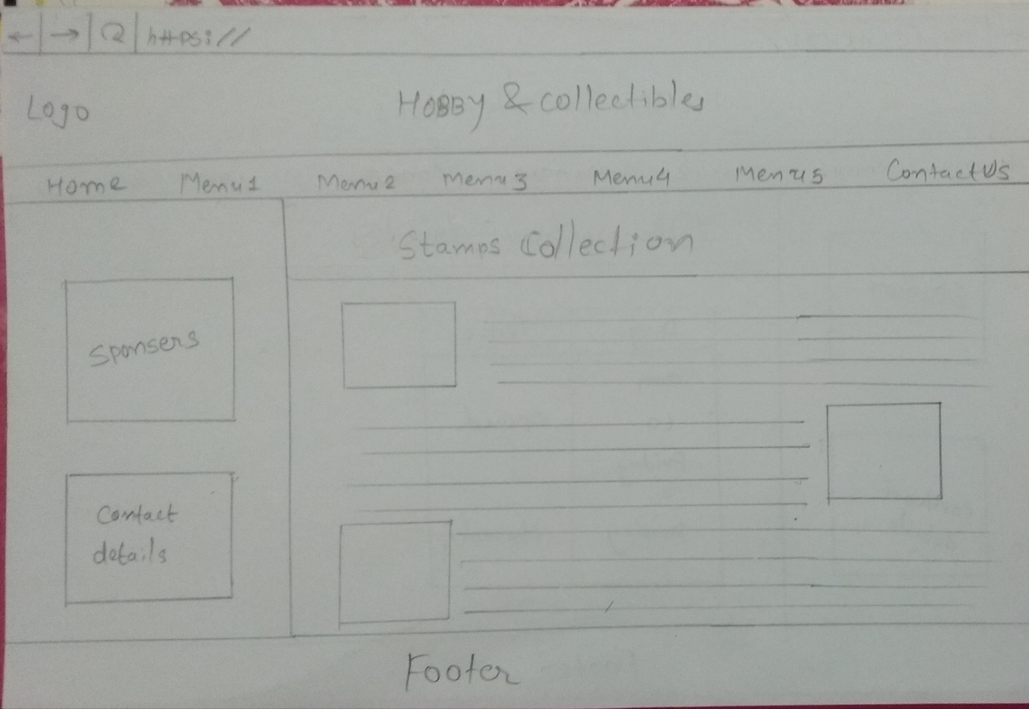

**Coins Collections**

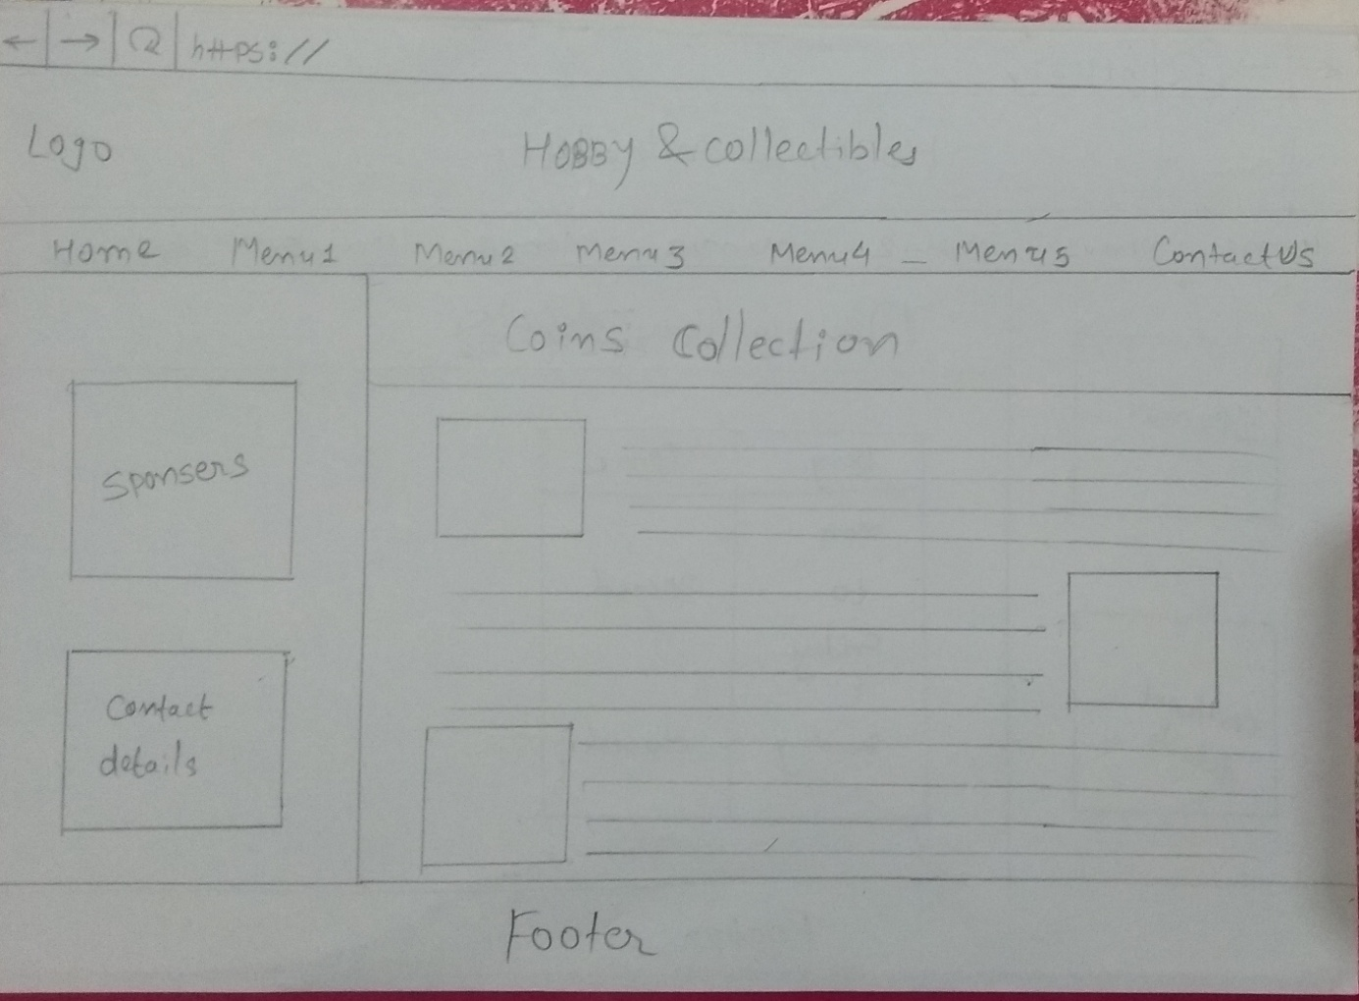

**Origami Collections**

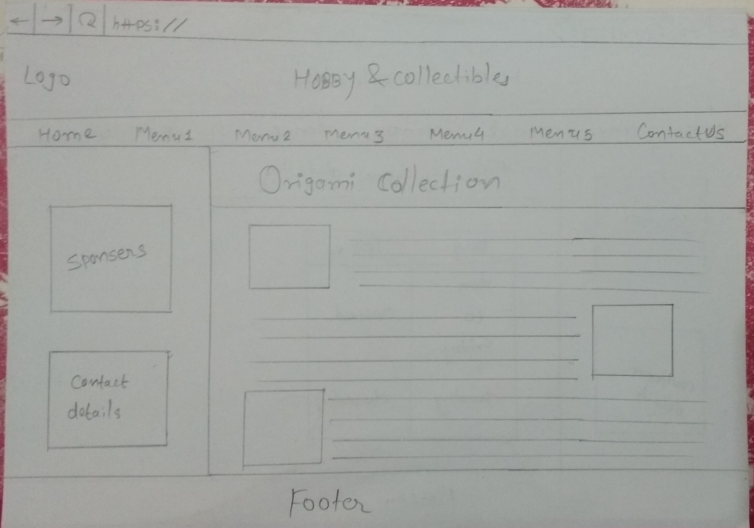

**Opening hours Detail**

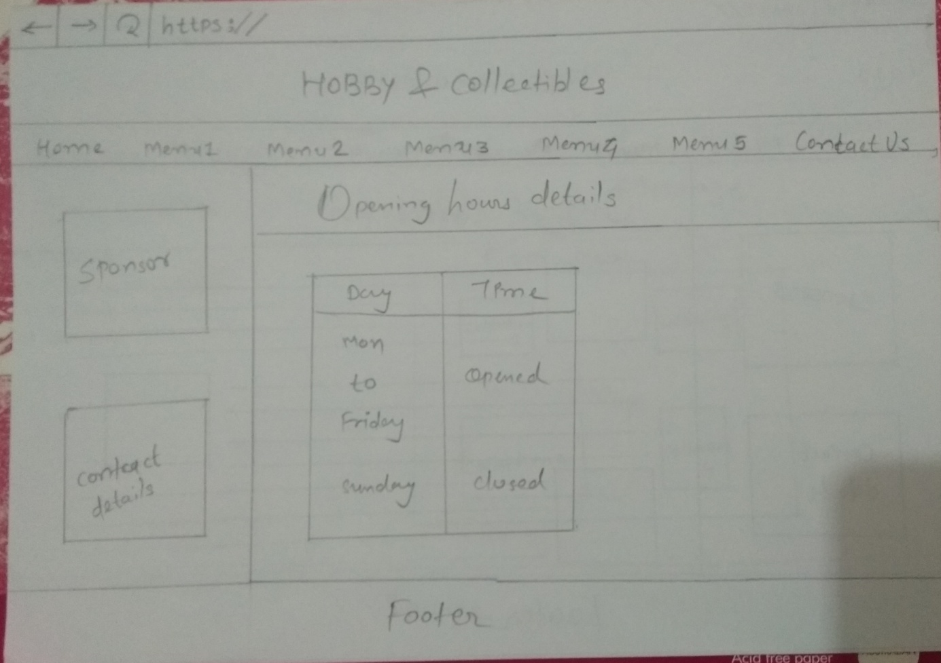

**Portfolio 2.2 (Chapter 8)**

According to the given detail every one of the pictures for site is accumulated from asset and as made site in down to earth assignment1 the greater part of the pictures are as of now utilized from that logo picture organization is PNG which offers straightforwardness alternatives so logo is straightforward and furthermore suite in light dark back-ground likewise there is void area between range tag and picture which adjusted it in the focal point of the header. The floor plan picture organization is JPG which is full shading photographic picture which set in landing page segment territory. some different pictures related specific robot type additionally has JPG design and with adjusted guest which are set with content substance so there is likewise void area among content and picture. What's more, different designs is additionally utilized for submit button with JPG position. Each picture has tallness and width and alt properties or seldom utilized title quality in picture henceforth, alt property shows alt content when picture doesn't show and title trait showcases title message as spring up when courser over the image. As appeared in site, hyperlink shading is reasonable with site logo picture and when it is clicked or visited its shading will change and set light blue shading.

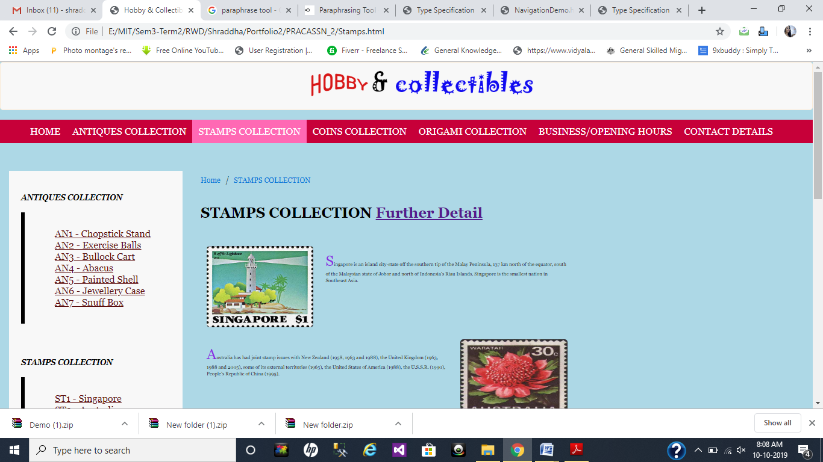

**Portfolio 2.3 (Chapter 9)**

The beneath figured flowchart portrays stream of client access on site. At the point when client will visit the landing page of site they can visit, floor guide of presentation in that floor map there will be four segment for various robots. At the point when client will tap on one of that segments they can divert on that specific robot page through hyperactive connection additionally they can get to that equivalent connection from landing page navigation. In option, client can have progression for in reverse and forward pages through which they can hop on the where they need or please that page from where they come. For my site, I fixed a structure by drawing designs of each page wherein I referenced header with logo, footer, sidebar, route, and substance page. This will assist client with accessing different pages from landing page effectively only by on a single tick. I likewise utilized breadcrumb idea through which client can get pecking order of got to page. the example arrangement of inward and outside route is appeared in underneath figure just as accessible in Navigation.html record.

Flow Chart

Entry

Visit Home Page

Access Origami Collections

Access Coins Collections

Access Antiques Collections

Get opening hours Details

Access Stamps Collections

Check shop opening hours details

Contact Details

Clients Emergency Exit

Exit

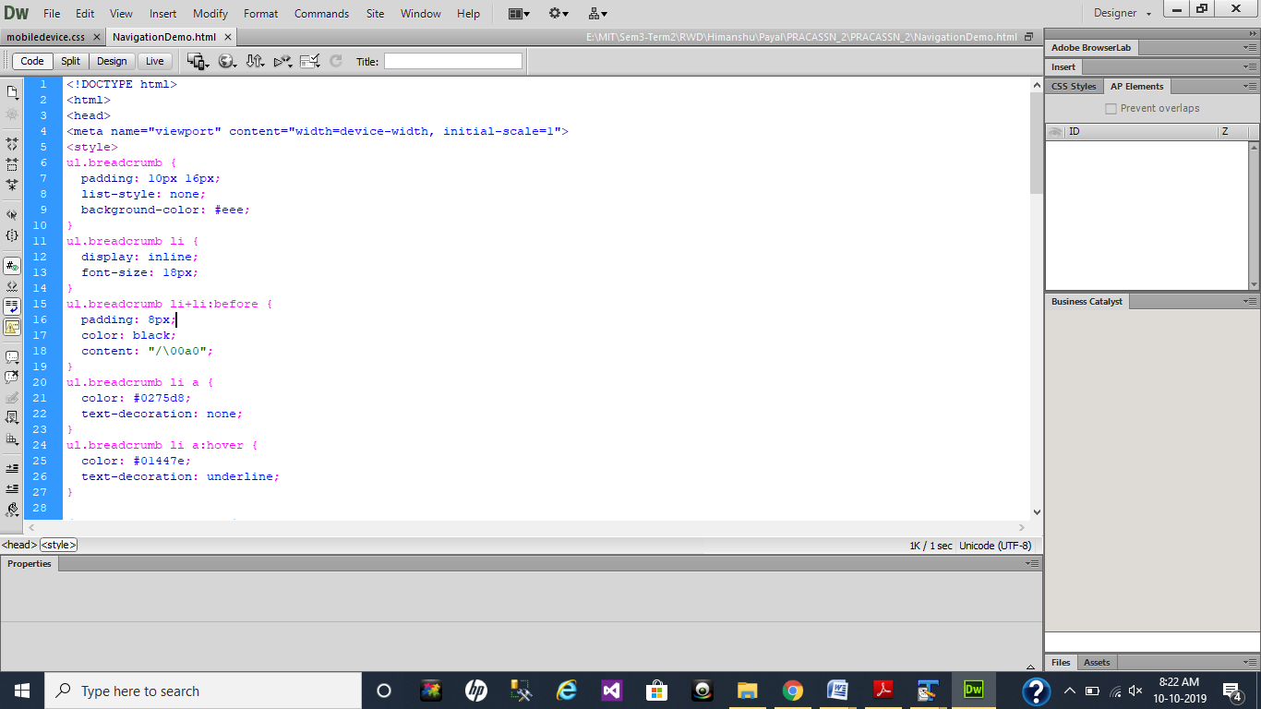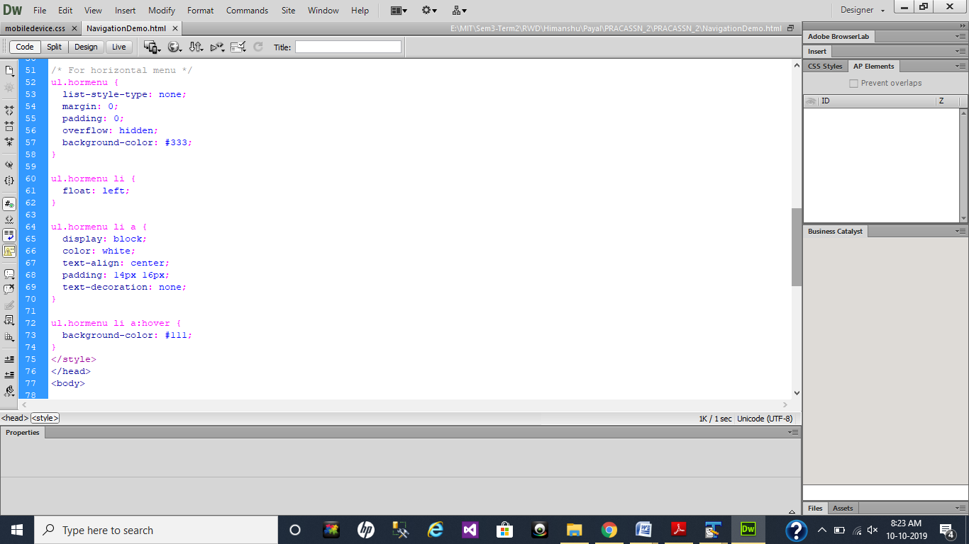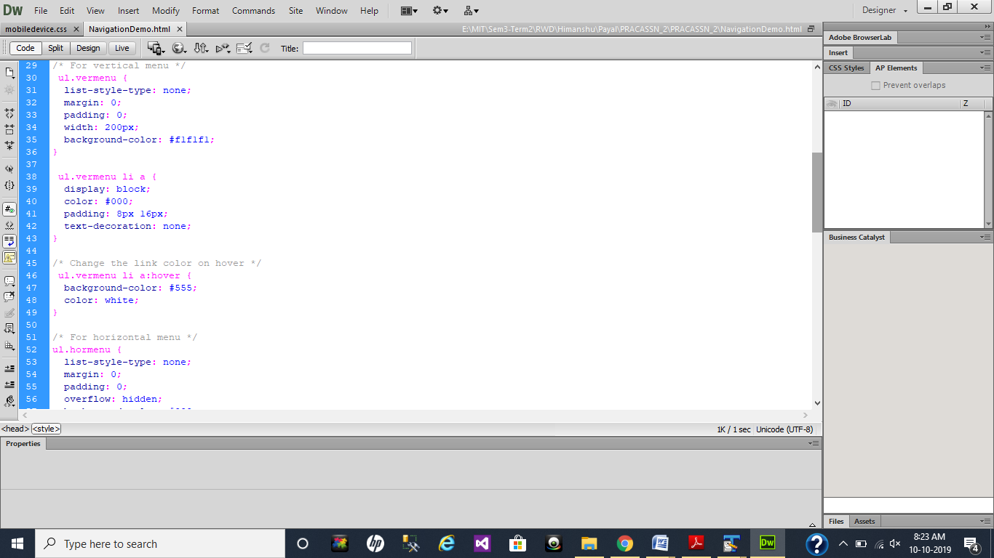

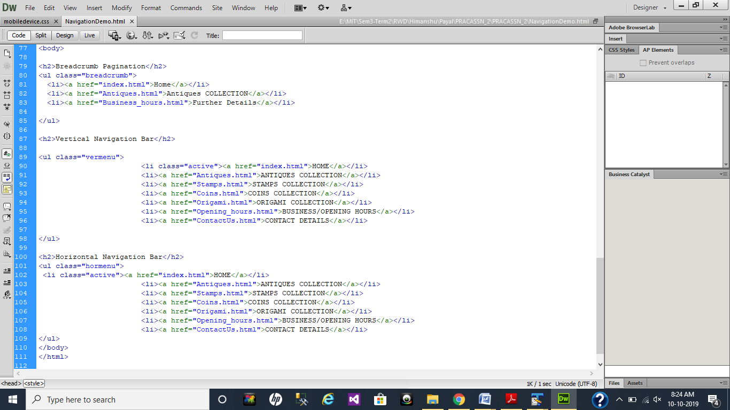

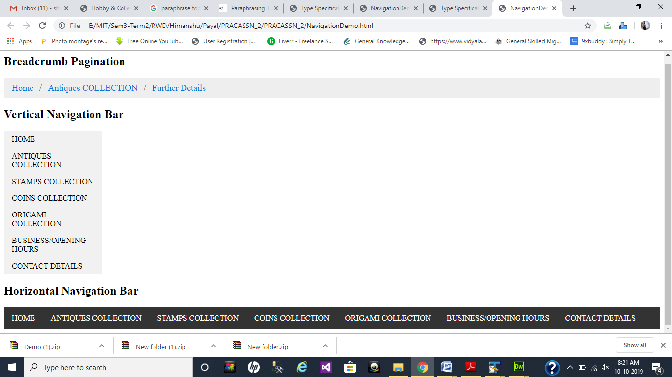

**Portfolio 2.4 (Chapter 10)**

After examining the content of given resource called as businesshours.txt, the given figure depicts that the given information is displayed in tabular form with highlighted notes.

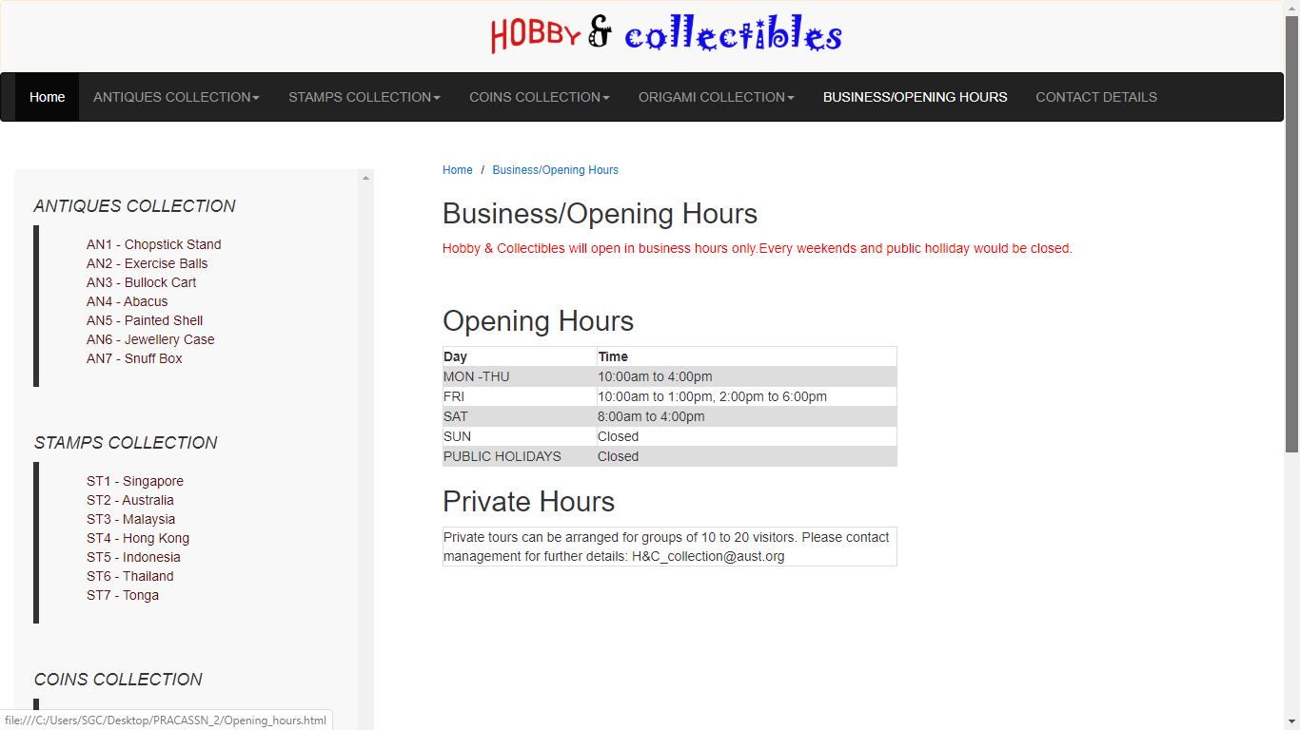

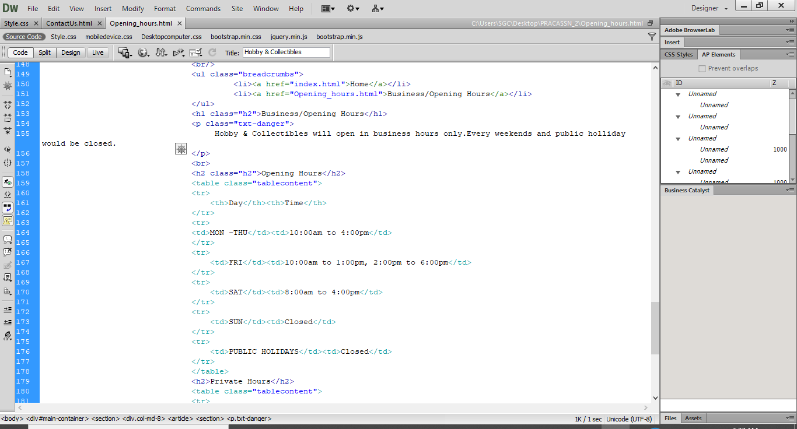

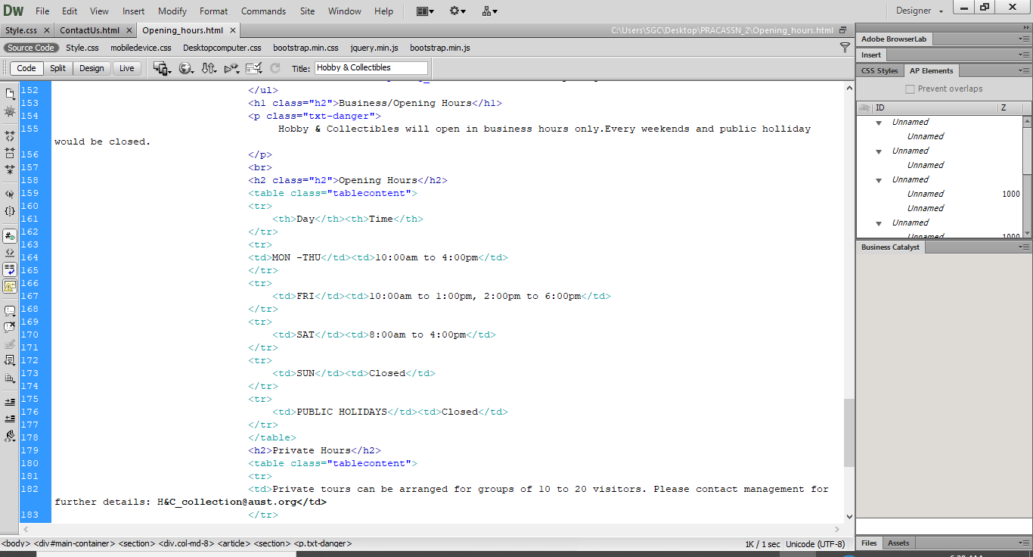

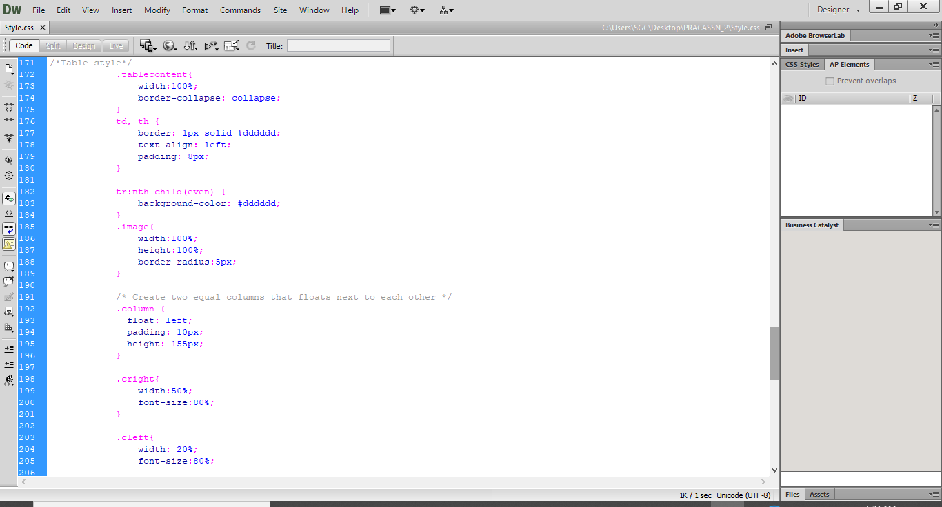

**Portfolio 2.5(Chapter 11)**

In given screenshot I display the contact details from in the website using form tag as well also used image for submit button which is in JPG format.

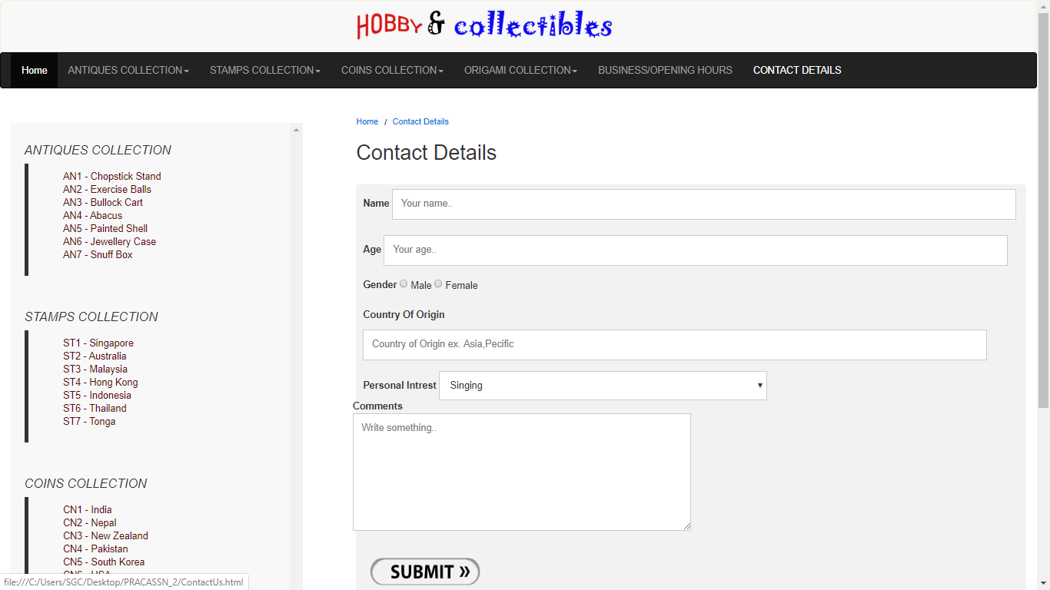

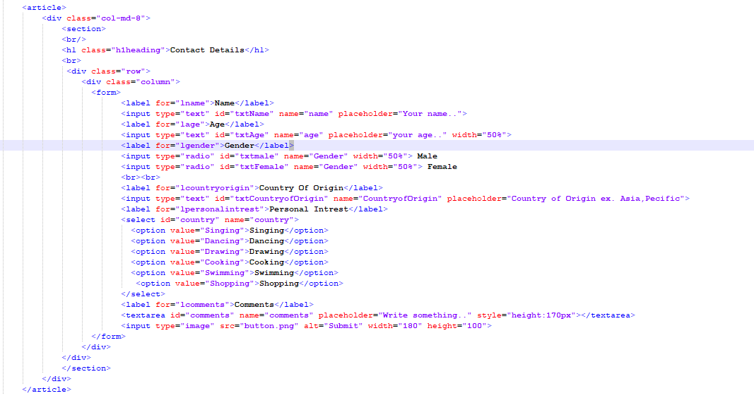

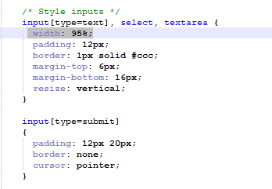

**Portfolio 2.6(Chapter 12)**

Subsequent to testing the site in various program finish the site and checked it similarity with web adventurer and Mozilla Firefox program. the given screen capture demonstrates that the site is responsive with adaptable format and furthermore perfect with given programs in even scene direction.

Testing in Chrome browser:

Mobile view

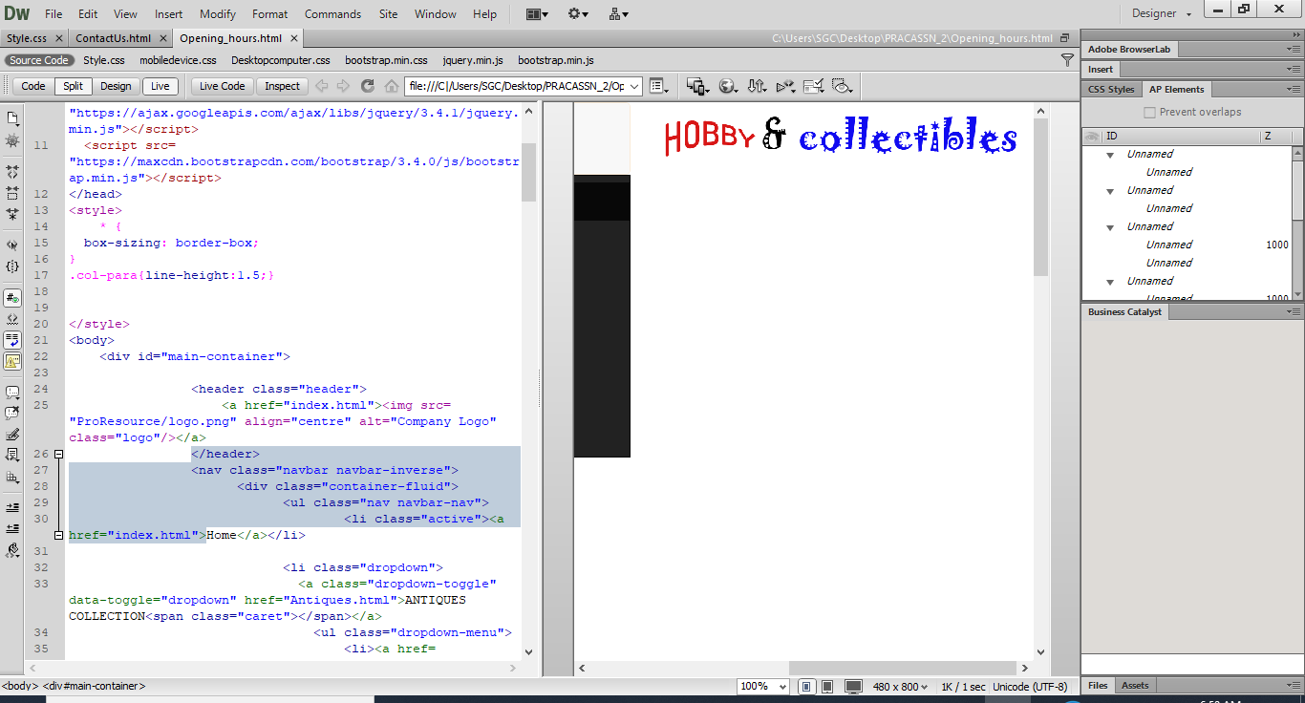

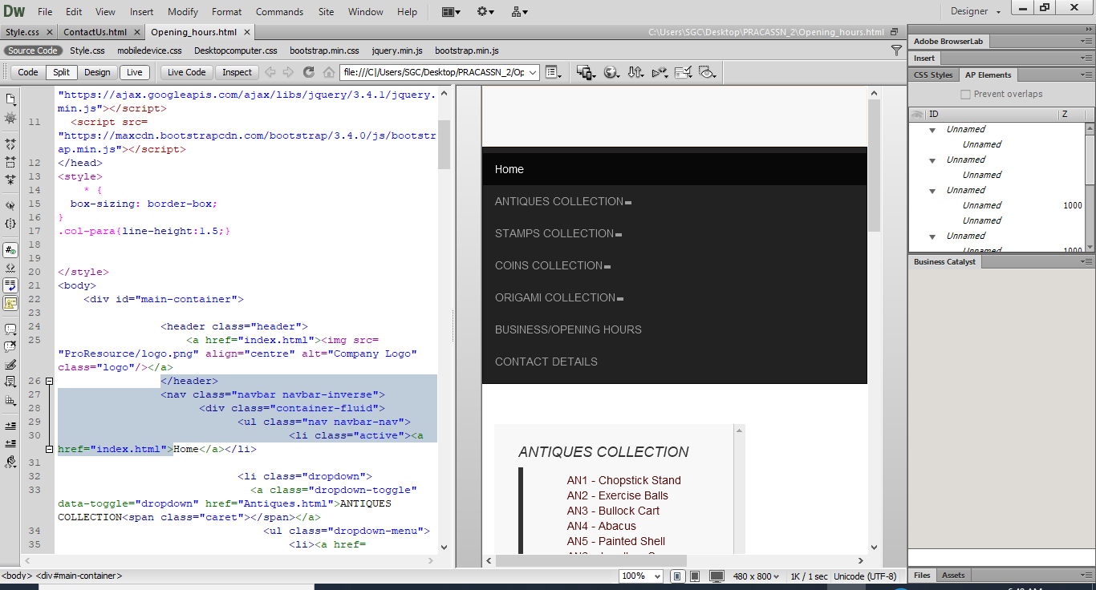

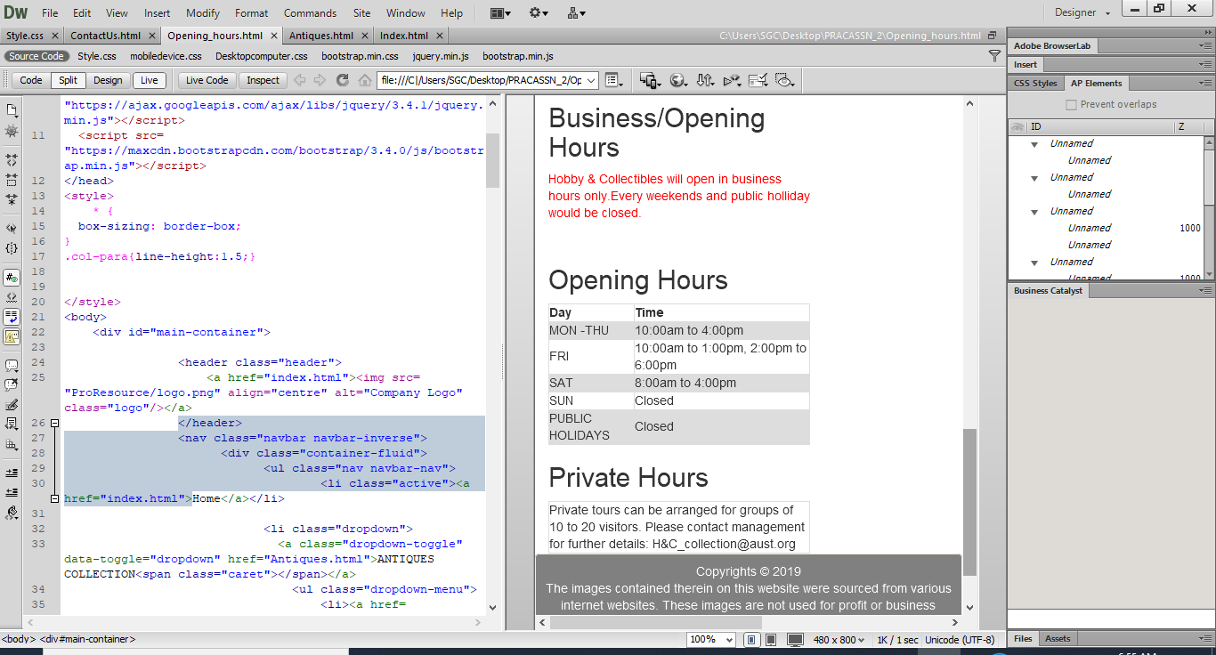

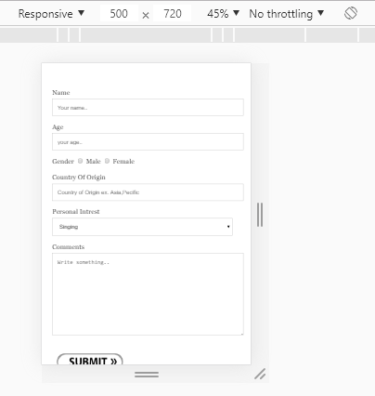

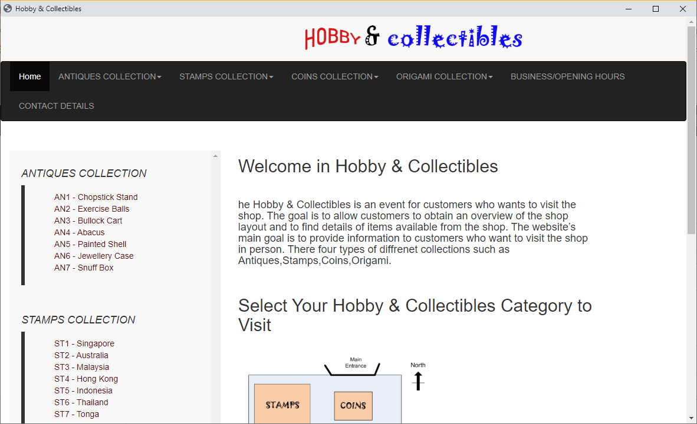

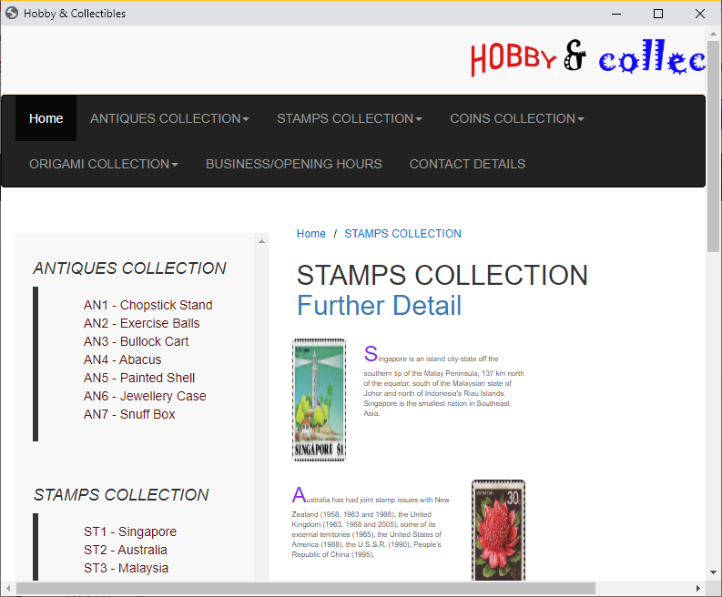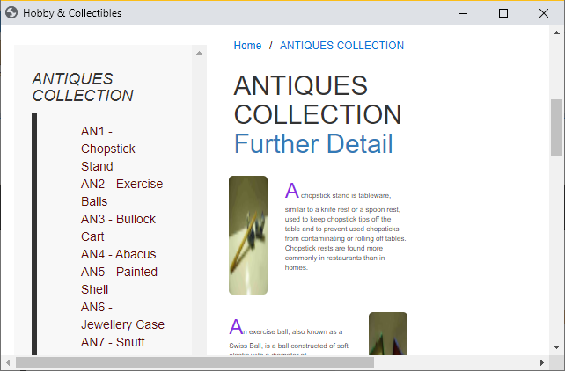

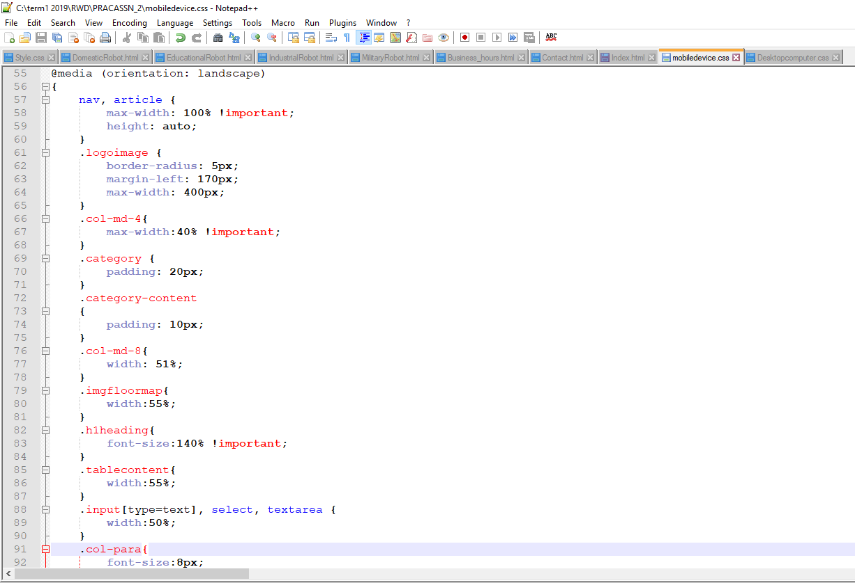

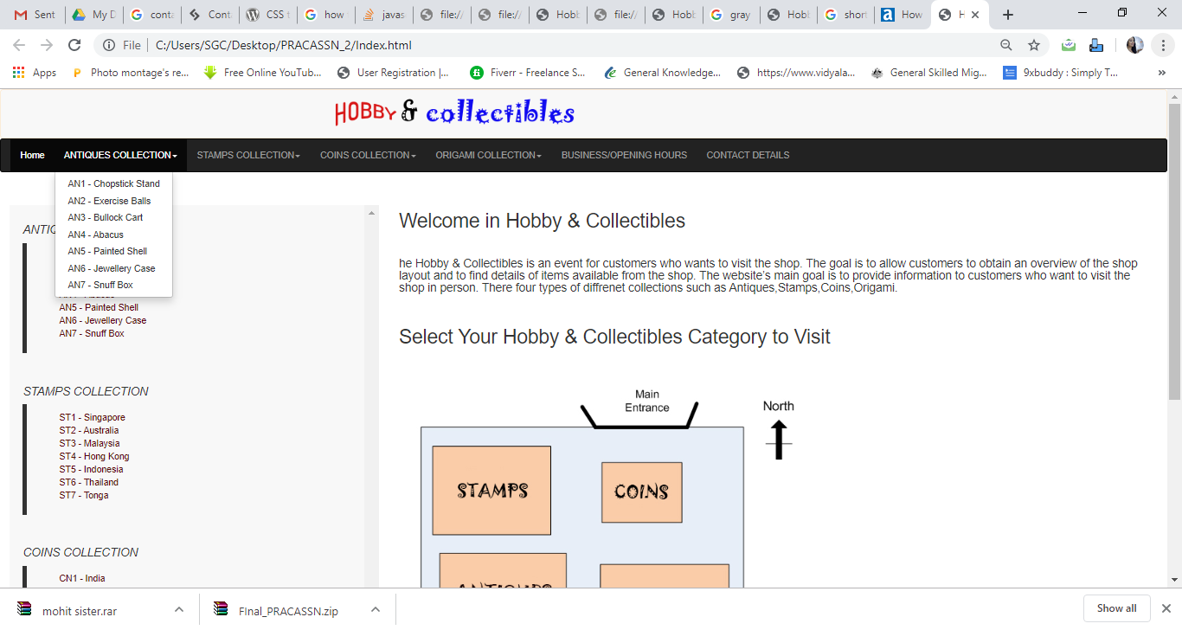

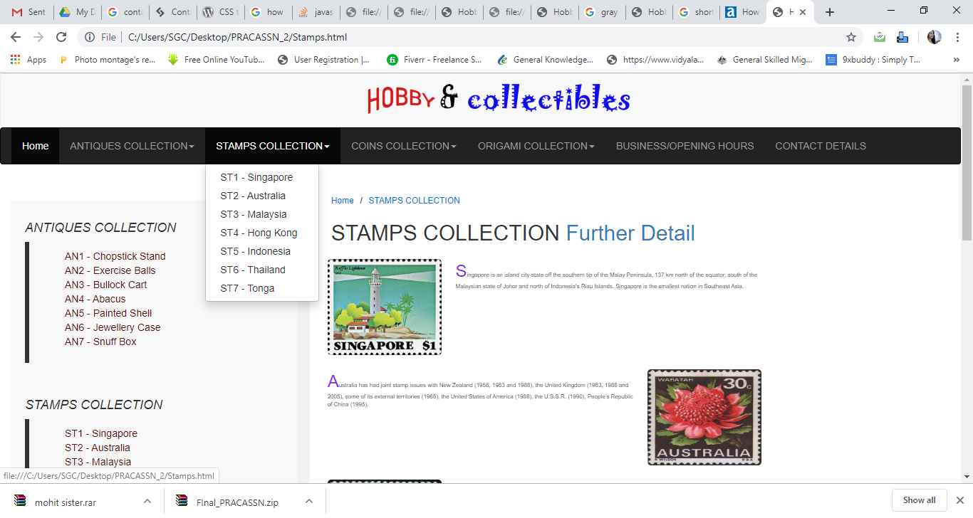

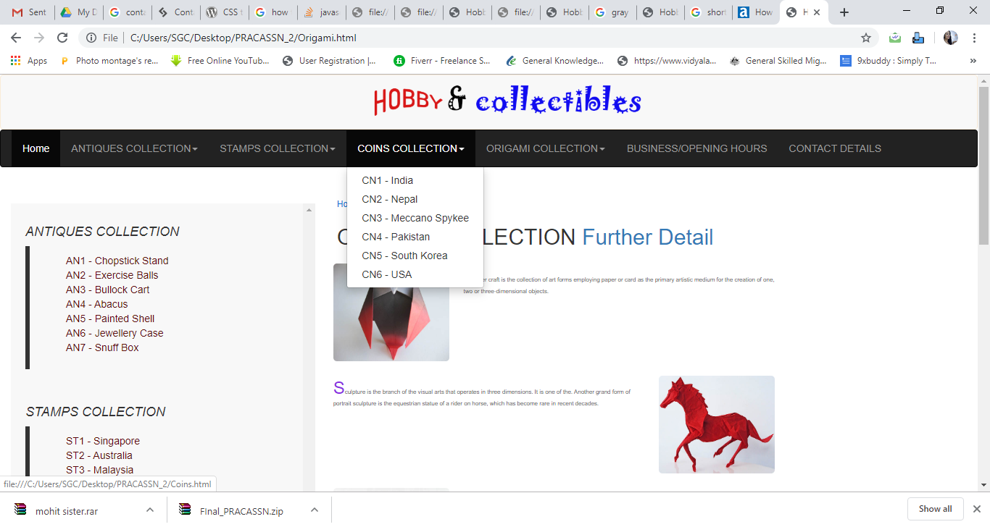

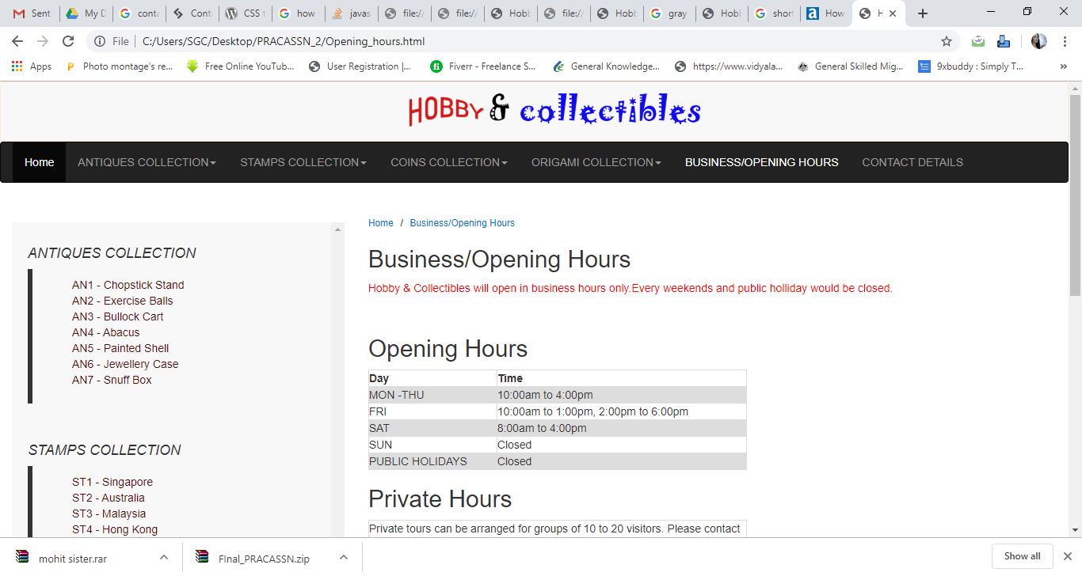

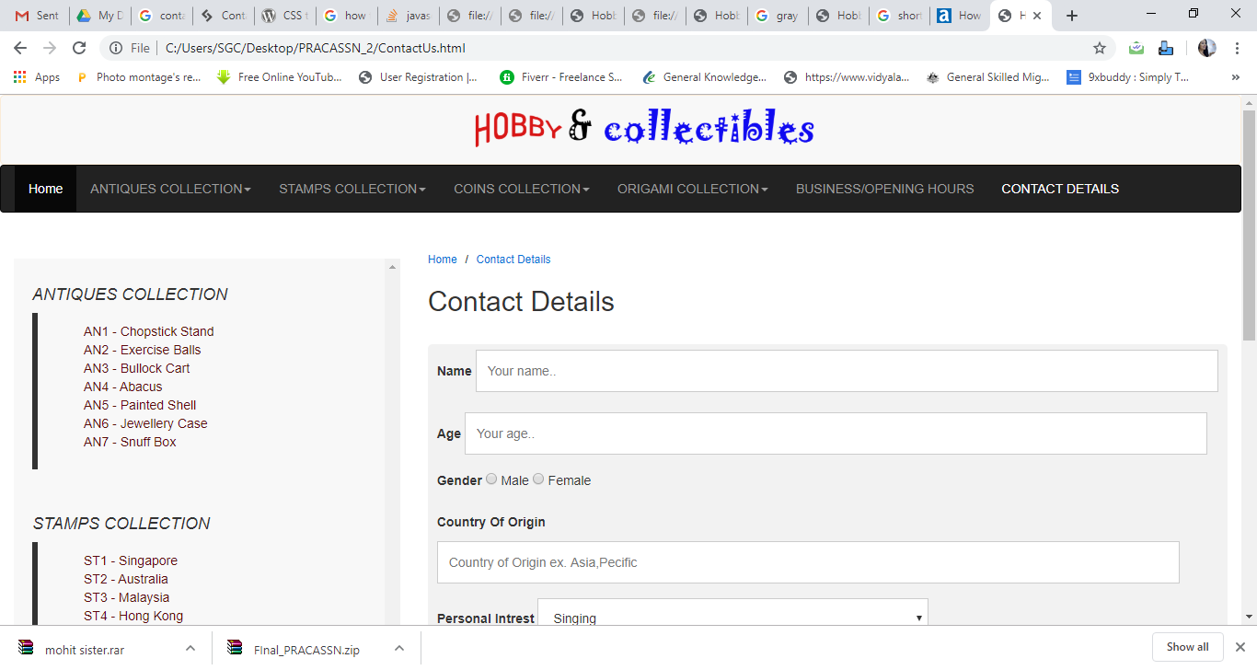

Testing in Internet Explorer browser: for this browser necessary changes is required for desktop device screen which shown below.

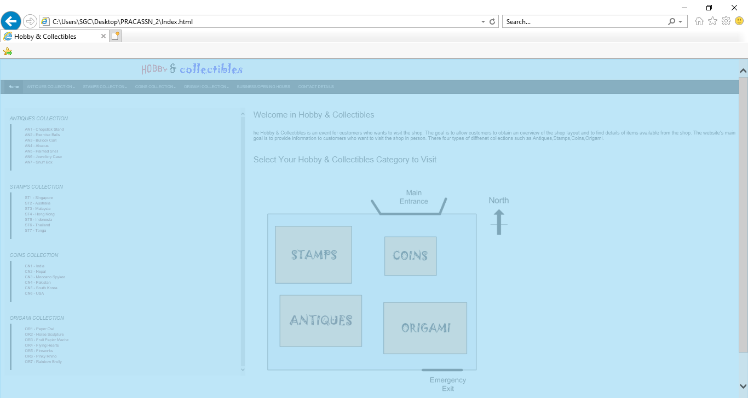

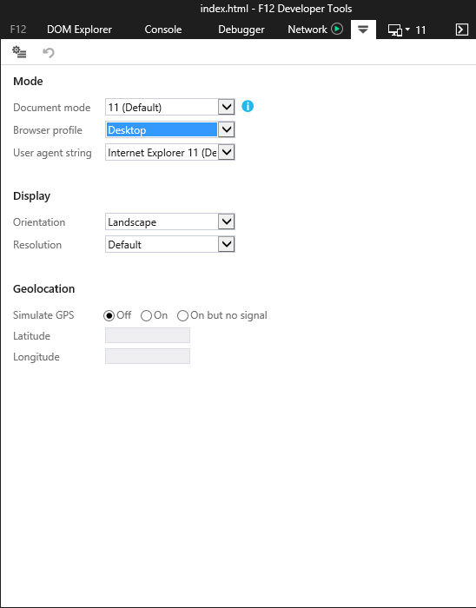

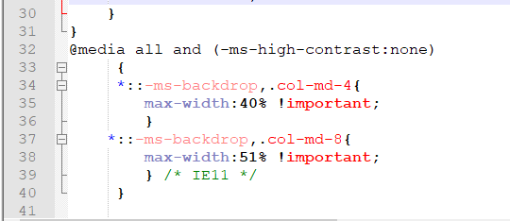

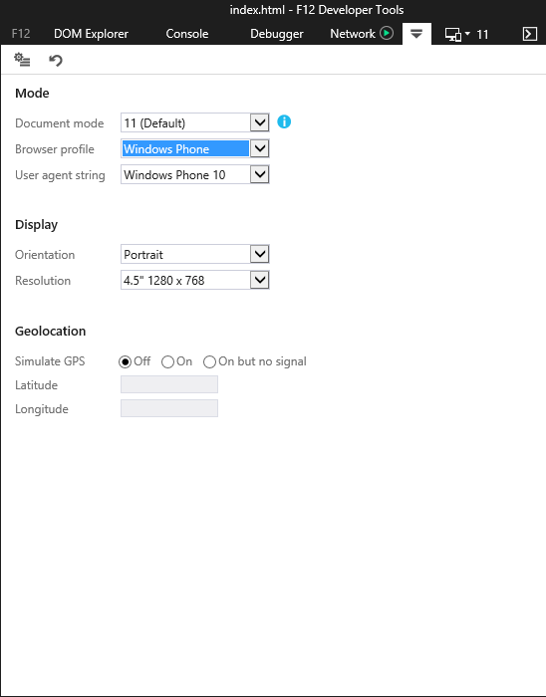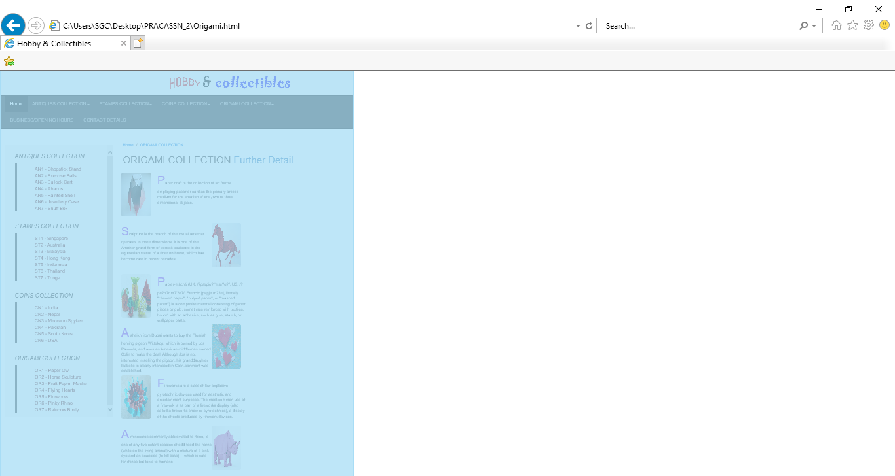

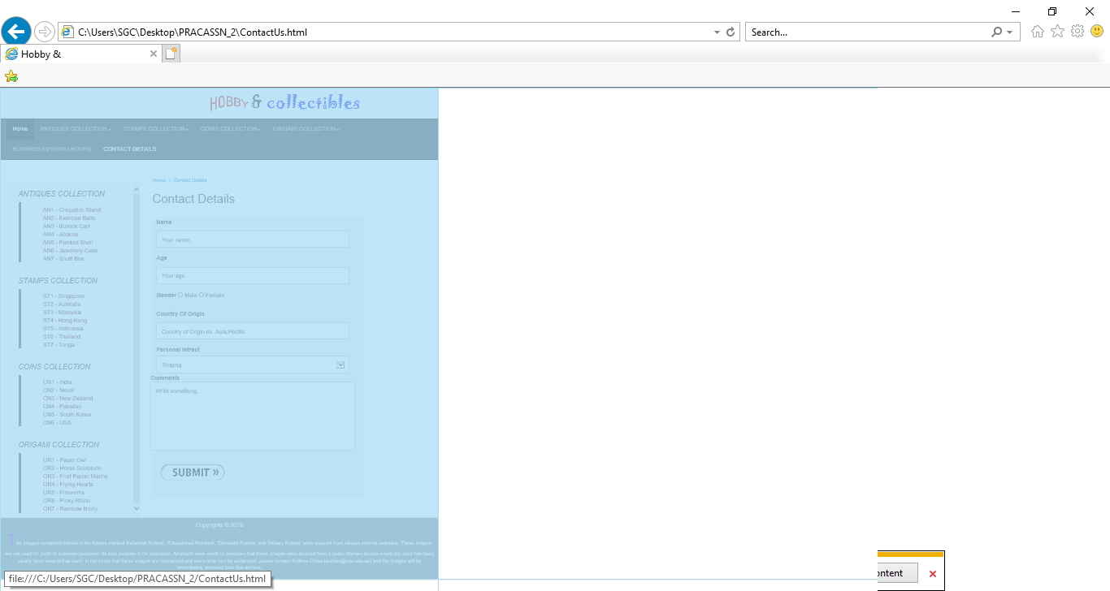

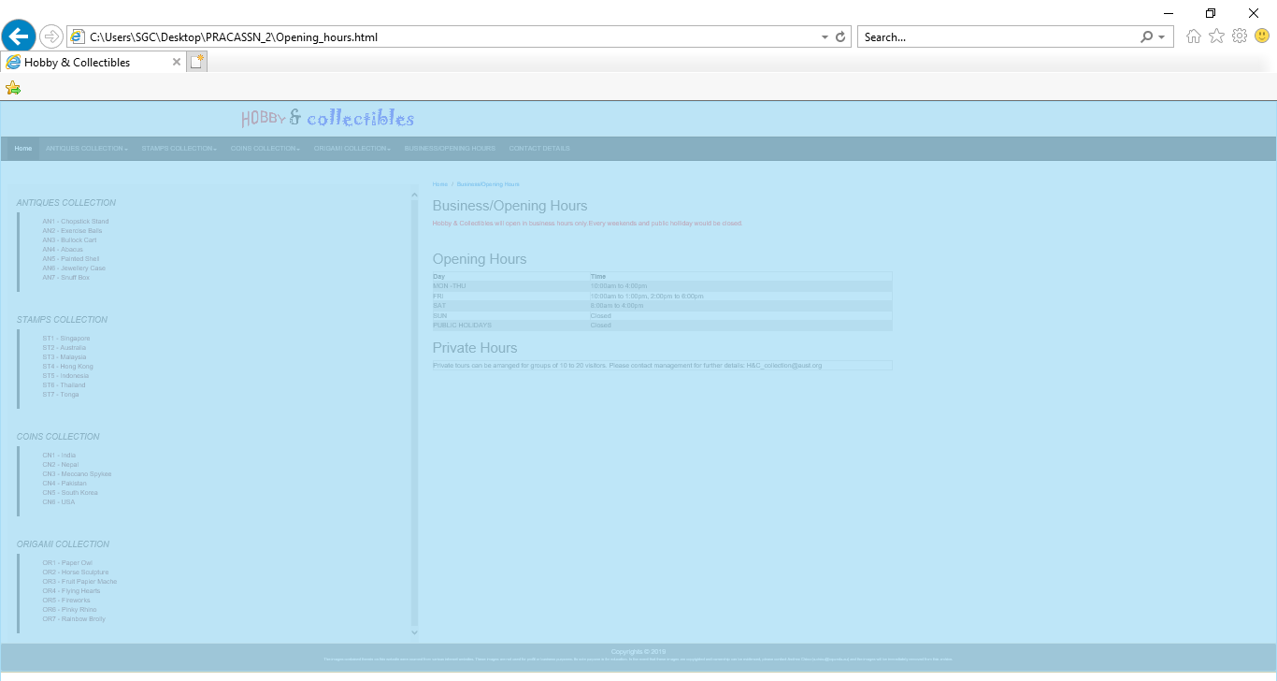



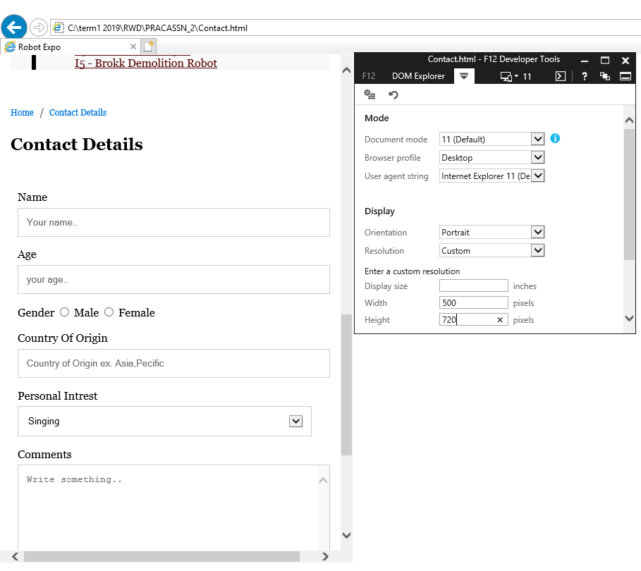

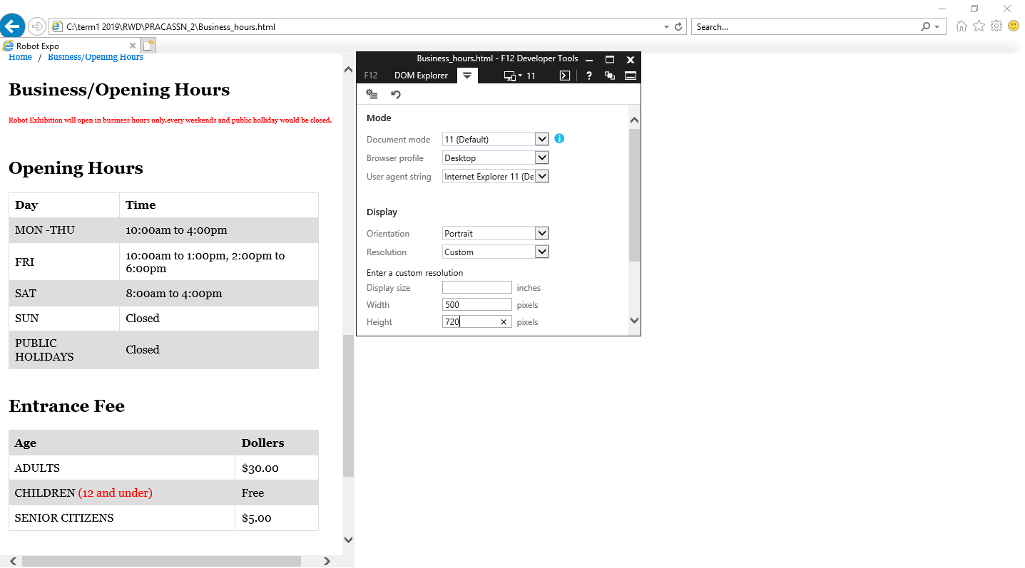

**Portfolio 2 -Summary**

At last in summary we can see all views of the website in mobile view, tablet view as well as in desktop view in different browsers such as chrome, Internet explorer and Mozilla Firefox.